F-44 -

Functionality
This function allows you to clear open items on the vendor account. It differs from posting with a clearing transaction or posting with a payment in the following ways:
- You do not need to enter a document header
- You can only clear open items from one account

Scenario
There are some postings on Vendor account (e.g. Invoice, credit memo and transfer posting) that are not cleared. You want to clear the postings.

Requirements
Not cleared postings on vendor account

Menu Path | Accounting → Financial Accounting → Accounts Payable → Account → F-44 – Clear.
Transaction Code | F-44
1. Double click on F-44 – Clear.

Clear Vendor: Header Data

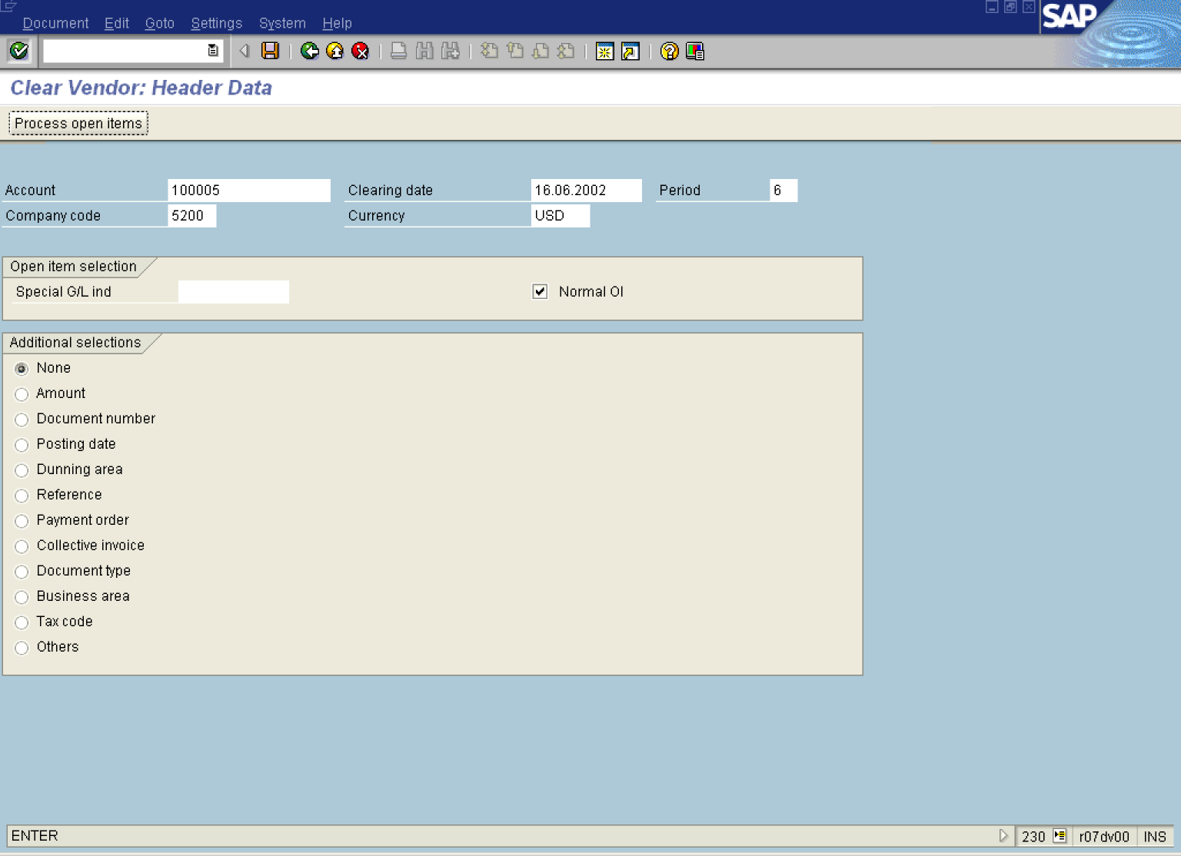

2. Update the following required fields:

Field Name | Description | Values
Account | Code identifying the Vendor account you want to clear | Example: 100005
Clearing date | Date when you want the transaction to be cleared. It is used later in a header of a clearing document. | Example: 16.06.2002
Company code | Number of the company code that the vendor belongs to | Example: 5200
Currency | Currency code. | Example: USD

Tip: You can clear also the transactions posted in different currencies. The system will automatically calculate and post exchange rate differences.

3. Click Enter Button . The system will display open items that fulfill previously entered criteria:

Clear Vendor: Process open items

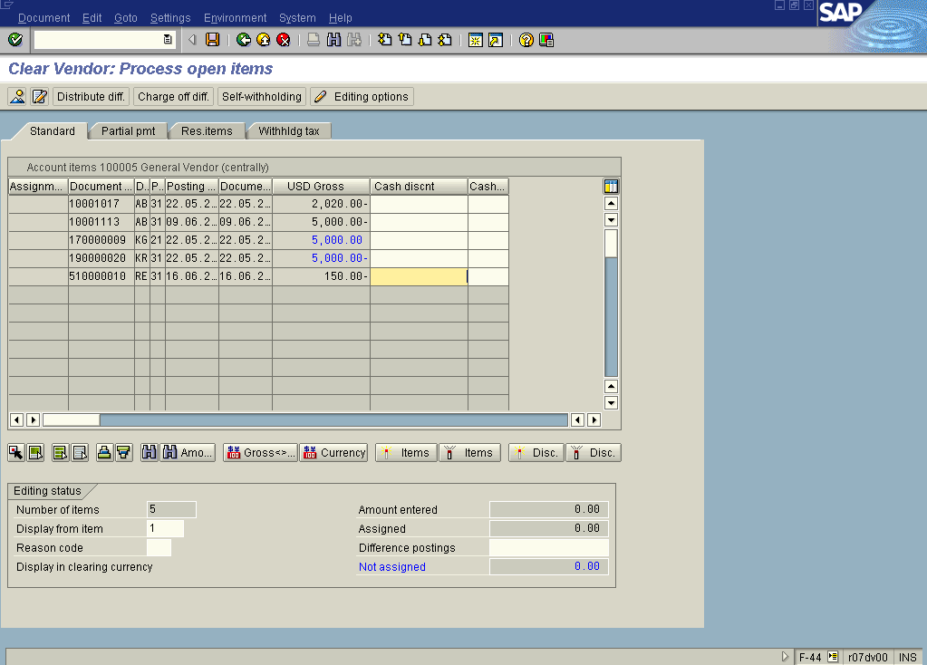

4. All open items are selected by default (later in this instruction how to change default system settings). To deselect the items first click Select all F7 Button .

5. Then click Deselect Items Button . All the open items are now not selected (they are no longer highlighted in blue).
6. Now you need to choose and select the items you want to clear. Double click on each of those items. E.g. choose documents 1700000009 and 19000020. The system will highlight these items in blue. The value of the field “Not assigned” is equal 0 and you can clear open items.

7. You can check your document before postings. Select DocumentSimulate.

Clear Vendor: Display Overview

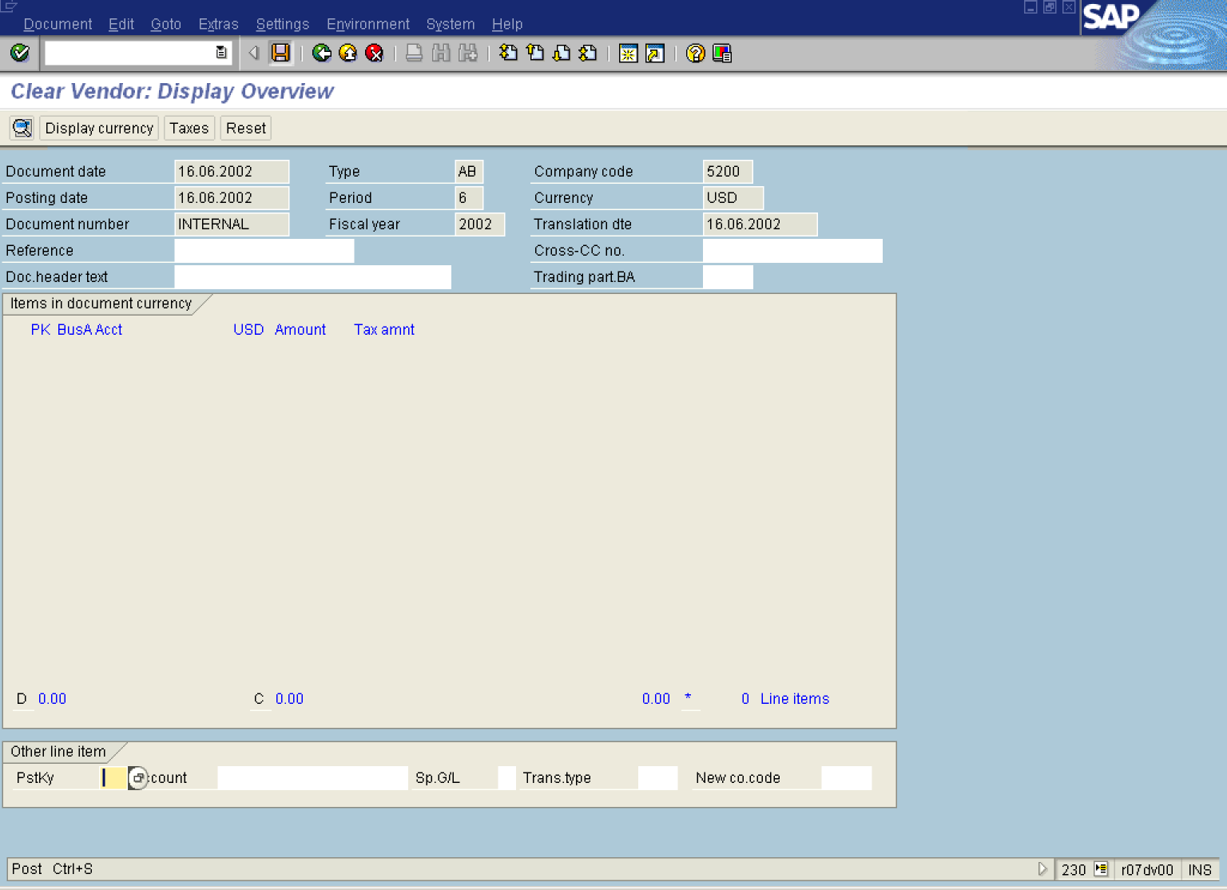

8. To post your entries, click Save Button.. No “real” posting took place, but the system stored a clearing document.

9. The message bar displays: “Document 10001151 was posted in company code 5200”.

Tip: If you want all your open items NOT TO BE SELECTED when you enter the clearing transaction, perform the following steps:

Clear Vendor: Header Data

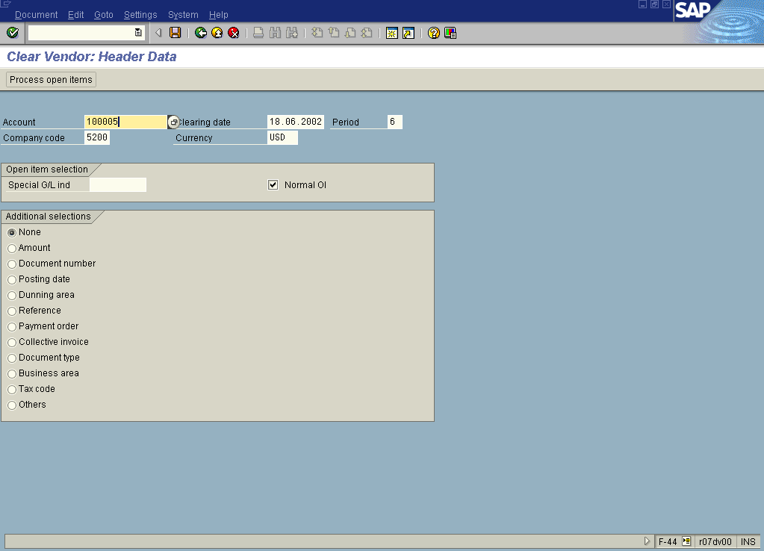

10. On the screen above use the following menu path: SettingsEditing options.

Accounting Editing Options

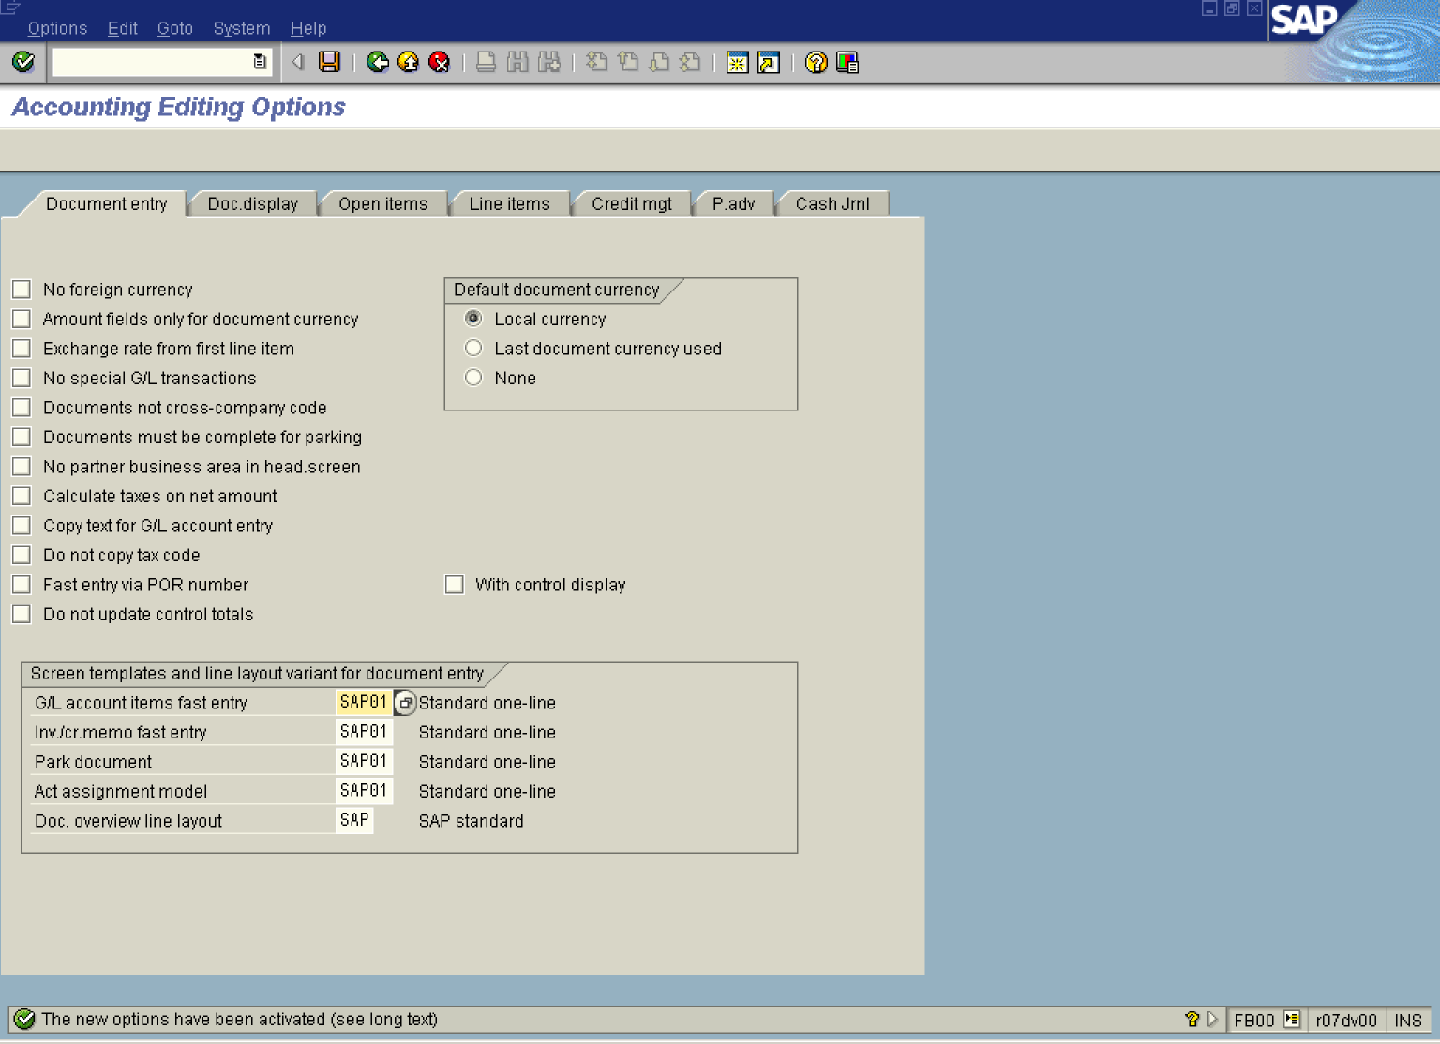

11. Click <tab button> Open items .

Accounting Editing Options

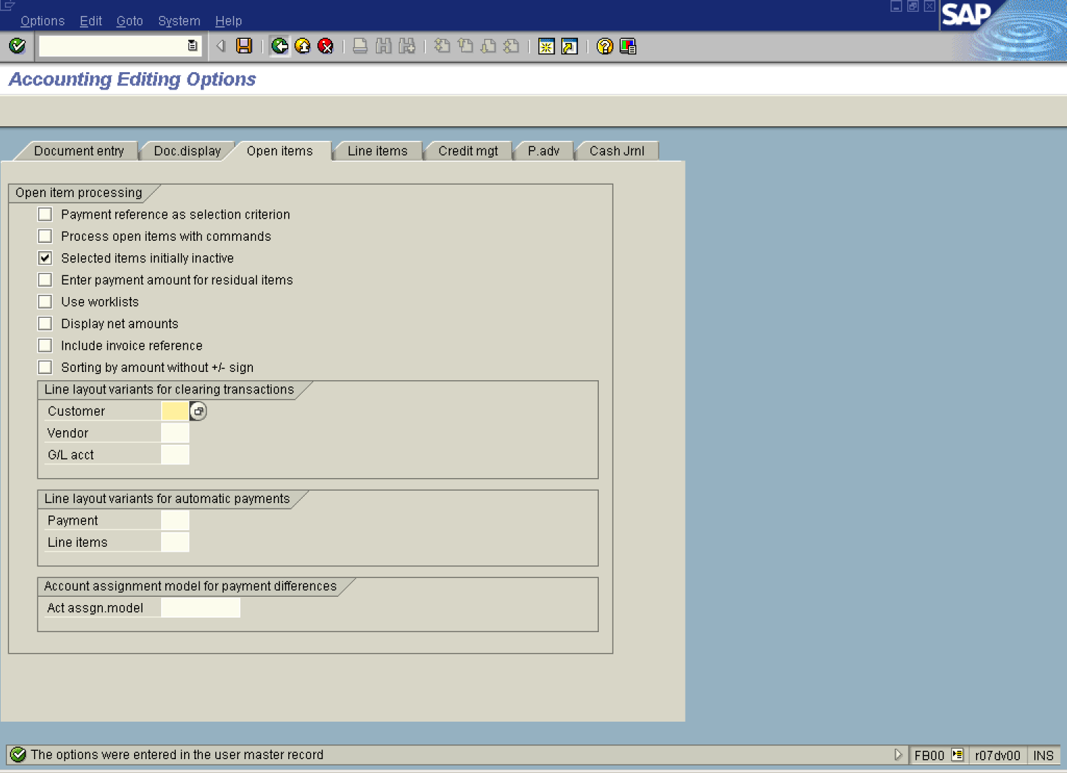

12. Click <checkbox> Selected items initially inactive .
13. Click Save Button.. The settings are now stored in user’s data.
14. Click Back Button . From now on, when you want to clear an account (Vendor, vendor or GL account), all the items will be initially inactive. You need to click on the selected items to activate them for clearing.

